CASE STUDY 6: ROBUST PASSWORD STRENGTH AUDIT AND VALIDATION SYSTEM
1 PROBLEM STATEMENT
Design and implement a secure password policy validation module that enforces minimum length requirements, mandatory character diversity (uppercase, lowercase, digits, special characters), character repetition limits, and checks against a blacklist of prohibited or common dictionary words to prevent weak credential creation.
2 OBJECTIVES
- Validate minimum character length constraints (e.g., $≥10$characters).
- Enforce the inclusion of uppercase letters, lowercase letters, numerical digits, and special symbols.
- Detect and restrict excessive consecutive character repetitions (e.g., maximum 2 consecutive identical characters).
- Screen passwords against a blacklist of common or vulnerable words using case-insensitive comparison.
- Generate detailed error logs and executive audit verdicts (PASS or FAIL) for candidate passwords.
3 KEY ASSUMPTIONS
Passwords are alphanumeric strings evaluated against predefined security policy configurations. Blacklist checks are case-insensitive to catch common bypass patterns like mixed-case variants of prohibited words.
4 ALGORITHM
- Define security configuration parameters (MIN_LENGTH, MAX_REPEAT, PROHIBITED words list, and SPECIAL_CHARACTERS).
- Verify password length; if below the minimum threshold, log a length failure message.
- Check character categories to ensure at least one uppercase letter, lowercase letter, digit, and special character are present.
- Walk through the string sequentially to track consecutive character runs; if any character repeats more than MAX_REPEAT times in a row, flag a repetition error.
- Convert the candidate password to lowercase and scan against the prohibited words list.
- Aggregate all validation error lists and output the final audit result.
5 FLOWCHART REPRESENTATION
Plaintext
[Start] -> [Read Password & Configuration Limits] -> [Check Length >= Min Length?]
-> [Check Character Categories (Upper, Lower, Digit, Special)]
-> [Check Consecutive Character Repetitions <= Max Repeat]
-> [Check Prohibited Words Blacklist (Case-Insensitive)]
-> [Any Errors? Yes: Mark FAIL with Details | No: Mark PASS] -> [End]
6 PSEUDOCODE
Plaintext
FUNCTION validate_password(password):
errors = []
errors.extend(check_length(password))
errors.extend(check_character_categories(password))
errors.extend(check_repetition(password))
errors.extend(check_prohibited(password))
RETURN errors

FOR pw IN sample_passwords:
problems = validate_password(pw)
PRINT password status and specific failure reasons if any
8 TEST CASES
Password Sample | Evaluated Criteria Status | Expected Result / Outcome
Tr0ub4dor&Horse | Meets length, category diversity, no excessive repeats or blacklisted words | PASS
short1A! | Length is 8 characters (below minimum threshold of 10) | FAIL (Too short: 8 characters...)
Passw0rd!!!!xyz | Contains 4 exclamation marks in a row (exceeds max repeat of 2) | FAIL (Character '!' repeats more than 2 times...)
9 OUTPUT SCREENSHOTS
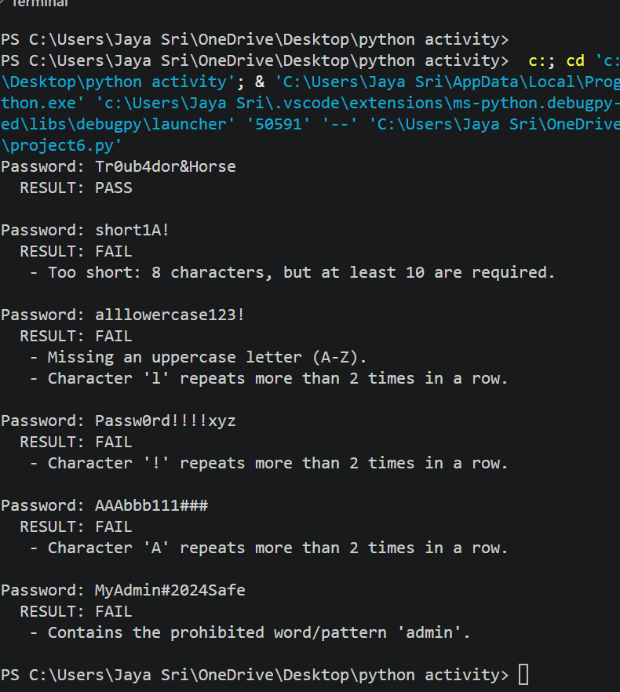
10 CONCLUSION
The robust password validation utility successfully automates multi-layered security compliance checks, effectively screening out weak, short, repetitive, and compromised credentials prior to system acceptance.

